Science Policy

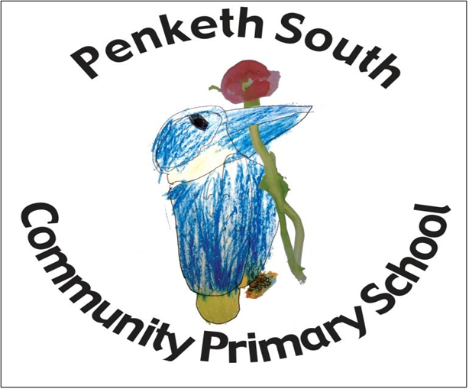

Aims
Science at Penketh South Primary School aims for children to:
- Develop scientific knowledge and conceptual understanding through the different disciplines of Biology, Chemistry and Physics and to ask questions to deepen their understanding;
- Develop understanding of the nature, processes and methods of Science through different types of science enquiries that help them to answer scientific questions about the world around them;
- Be equipped with the scientific knowledge required to understand the uses and implications of Science, today and for the future.
- Develop the essential scientific enquiry skills to deepen their scientific knowledge both independently and when working with others.
- Use a range of methods to communicate their scientific information and present it in a systematic, scientific manner, including I.T., diagrams, graphs and charts.
- Develop a respect for the materials and equipment they handle with regard to their own, and other children’s safety.
- Develop an enthusiasm and enjoyment of scientific learning and discovery.
- Encourage children to treat the living and non-living environment with respect and sensitivity

Skills and Attributes
Through the teaching of Science at Penketh South, children will develop a range of skills and attributes that not only contribute to their Scientific education but also clearly contribute to the whole school curriculum.
- Learners for Life
  - Enthusiastic
  - Committed
  - Motivated
  - Inquisitive
  - Critical thinker
  - Independent
  - Determined
  - Lover of learning
  - Organised
- Powerful Contributors
  - Ability to work as part of a team
  - Appreciative of others’ contributions and a willing to praise others
  - Active learner
  - Resilient
  - Ability to problem solving and think creatively
  - Accountable
- Confident Individuals
  - Confident
  - Ability to recognise own strengths
  - Ambitious
  - Self-belief
  - Proud
  - Strives to improve
  - Positive
  - Courageous
- Responsible Citizens of the Future
  - Ability to Understand, appreciate, accept and promote equality, diversity and inclusivity.
  - Respectful
  - Tolerant
  - Environmentally aware
  - Responsible
Science in EYFS
Science is taught in Early Years within Understanding the World. Science makes a significant contribution to developing a child’s knowledge and understanding of the world, for example through exploration and investigation of what floats and what sinks when placed in water. The Early Years children also take part in the forest schools programme which includes environmental science. For more information, please see the EYFS curriculum progression document.

Key Stage One
In Key Stage 1, pupils observe, explore and ask questions about living things, materials and the world around them. They begin to work together to collect evidence to help them answer questions, find patterns, classify and group objects and carry out fair testing. Pupils use reference materials to find out more about scientific ideas. They share their ideas and communicate them using scientific language, drawings, diagrams and tables. Science lessons in Key Stage one are either taught discretely or where possible connected to other curriculum areas. Pupils often use the outdoor areas in their science learning.

Key Stage Two
In Key Stage 2, pupils learn about a wider range of living things, materials and physical processes. They make links between ideas and explain things using simple models and theories. They apply their knowledge and understanding of scientific ideas to familiar phenomena, everyday things as well as their personal health. They think about the effects of scientific and technological developments on the environment and in other contexts. They carry out more systematic investigations, working on their own and with others. They use a range of reference sources in their work. They talk about their work and its significance, using a wide range of scientific language, conventional diagrams, charts, graphs and ICT to communicate their ideas.

Teaching & Learning
Wherever possible Science work will be related to the real world and everyday examples will be used to link understanding. Teaching has a focus upon scientific enquiry and a variety of strategies, including; questioning, discussion, marking and observation are used to assess progress. Lessons include a variety of activities to support the children’s retention of scientific vocabulary and facts. These retrieval tasks aid and encourage the children to use technical language appropriately, remember important facts and make links to previous learning. Lessons make effective links with other curriculum areas and subjects, especially Maths, English and ICT. Pupils have frequent opportunities to develop their skills in, and take responsibility for, planning investigative work, selecting relevant resources, making decisions about sources of information, carrying out activities safely and deciding on the best form of communicating their findings.
Role of the Science Coordinator
The Subject Leader should be responsible for improving the standards of teaching and learning in Science through:
- Monitoring and evaluating pupil progress
- Provision of Science at Penketh South
- The quality of the Learning Environment
- Supporting colleagues in their CPD
- Auditing, purchasing and organising resources
• Keeping up to date with changes in the subject – attending training regularly

Health and Safety
Pupils will be taught to use scientific equipment safely when using it during practical activities. Class Teachers, Teaching Assistants and the Subject Leader will check equipment regularly and report any damage, taking defective equipment out of action. Where needed and when necessary, risk assessments will be completed prior to practical and investigative work.

